Logistics Guideline

These guidelines have been developed to provide assistance to Event Manager coordinating event logistics in APH.
General
All goods, materials, tools, equipment, waste and debris should be delivered and removed through the APH Loading Dock. Goods that cannot be screened at building entrances (600m x 400mm maximum) may be refused entry and redirected to the Loading Dock.
Operating hours
The Loading Dock operates from 7:00am to 4:45pm, Monday to Friday (excluding Public Holidays).
Requests to open the Loading Dock outside of these hours require a minimum of 5-days’ notice. The contractor will be responsible for meeting all costs associated with afterhours opening of the Loading Dock.
Pre-delivery advice
All deliveries to the Loading Dock must be scheduled with a minimum of 24-hours’ notice.
Deliveries of bulk goods (e.g. large quantities of oversized goods such as furniture, machinery, palletised goods, building materials) require up to 5-days’ notice. For unusual or very large items (e.g. custom stage sets) please attach photos and approximate dimensions of the items to the booking.
Receipt and distribution of goods with insufficient notice will be processed behind that of any priority deliveries and will be attended to on a ‘first in-first out’ basis.
Same-day delivery appointments will not be accepted and vehicles may be refused entry.
Deliveries to the Loading Dock can be made by completing a Booking Form (available on the DPS Intranet or by contacting your DPS Event Manager) and submitting it to Loading Dock: loadingdock@aph.gov.au.
All deliveries must specify a basement set down point.
The maximum width of the basement is 2300 mm
The maximum height in the basement is 2500 mm.
Access to the Loading Dock
Access to the Loading Dock is via a service road that connects the Loading Dock to the junction of Brisbane Ave and State Circle.

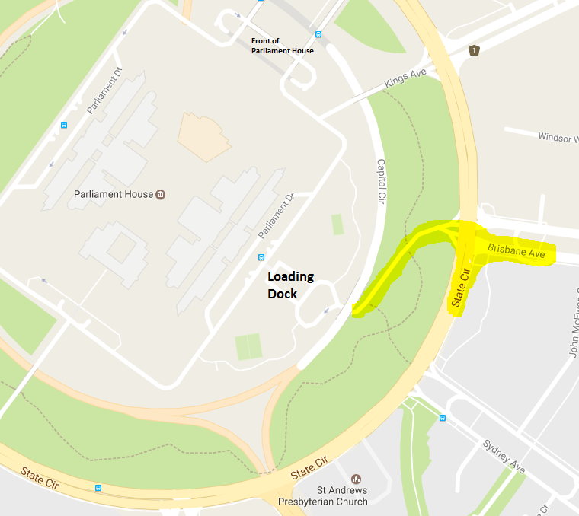
Contractors/clients must ensure that drivers of their delivery vehicles are aware that:
(a) They must:
- stop at the ‘stop sign’ and only proceed if the Security Check Zone is clear
- stop in the Security Check Zone and wait for their vehicle details to be checked
- wait for the barrier to open before proceeding
- give way to vehicles leaving the site
- use the intercom system to contact PSS Officers if the barrier does not open within 1 minute
(b) Only 1 vehicle can pass through the barrier at a time and the gate will be closed after each vehicle has entered
(c) Tailgating is not permitted and will be treated as a Security Breach.
(d) The Loading Dock and associated road ways are considered ‘shared zones’ and a speed limit of 5Km/h must be adhered to.

Receipt, handling and distribution of goods
Logistics personnel accept goods on assessment, i.e. the number of packages and / or containers, compared with the delivery documentation, and their condition on arrival. Logistics personnel will not open packages to check the quantity or condition of contents.
Any discrepancies or damage to goods or packaging must be highlighted to the delivery driver and details of the discrepancy or damage must be annotated on the drivers’ copy of the delivery documentation.
It is the responsibility of the contractor/client to ensure that all goods are correctly addressed. Logistic personnel are empowered to reject any deliveries when the intended recipient cannot be ascertained from the delivery documentation, package markings or delivery advice.
It is the responsibility of those delivering or the receiving the goods to handle delivered items on and off the x-ray machine, and/or on and off trailers or pallets. In view of that clients should arrive with enough people to facilitate this.
Logistics Personnel do not handle delivered items, on and off the x-ray machine, or on and off trailers or pallets.
Trailers must be unloaded as soon as possible after delivery and the Loading Dock notified once empty.
Trailers are not be used for storage of goods / equipment long term or overnight, without the consent of the Logistics Team.
APH has limited onsite storage which is available at the discretion of DPS. Materials should be stored offsite where possible.
Goods Lift
The dimensions of the Goods Lift are:
Width 2400 x height 3500 x depth 3000
The goods lift has 4000kg capacity

Logistics’ Trailer information
Type | Number | Data
Large  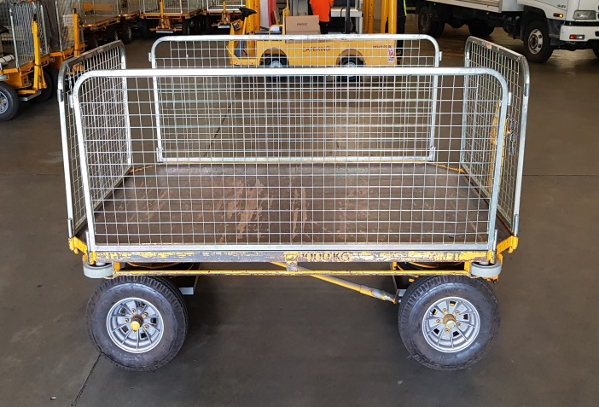 | 14 | - Maximum Load: 1000kgs  - Load deck width 1380mm  - Load deck length 2200mm  - Gate Height 780mm  - Deck Height 624mm
Flatbed Trailers  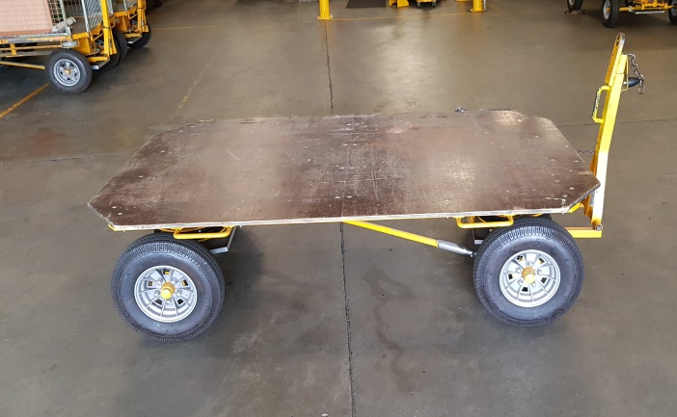 | 3 | - Maximum Load 1000kgs  - Load deck width 1450mm  - Load deck length 2400mm  - Deck Height 600 mm
Small caged Trailers (only available on request)  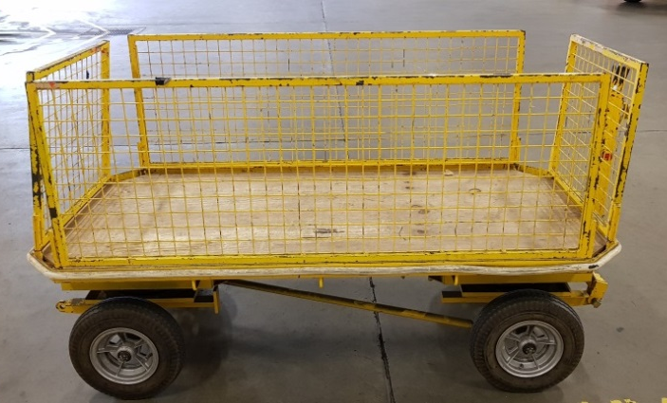 |  | - Maximum Load 600kgs  - Load deck width 940mm  - Load deck length 1930mm  - Gate Height 630mm

